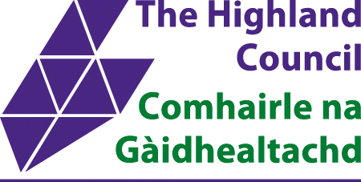





Digital Learning in Highland

Parent/Carer Advice

Scottish Government's Digital Learning & Teaching Strategy
Why do we want learners to have a personal device?
How Does Digital Technology Enhance Learning & Teaching?
Highland Digital Learning Website
G Suite for Education Pupil Training Guide
Safe and Responsible Use of Digital Technology
1. Be Secure
2. Be Respectful
3. Be Safe
4. Be Responsible
5. Be Legal
Tips for Parents and Carers
What we expect from pupils
What won’t change?
Safety & Security
Chromebook FAQ
What kind of software does a Chromebook run?
How are these web-based applications managed?
What devices can I connect to a Chromebook?
Can the Chromebook be used anywhere at any time?
Do Chromebooks come with Internet Filtering Software?
Is there antivirus software built in?
What is the battery life?
Can I use my personal Google account for school?
Can I print from a Chromebook?

This is a live document and more information will be added to it as we get closer to the rollout.

Scottish Government's Digital Learning & Teaching Strategy
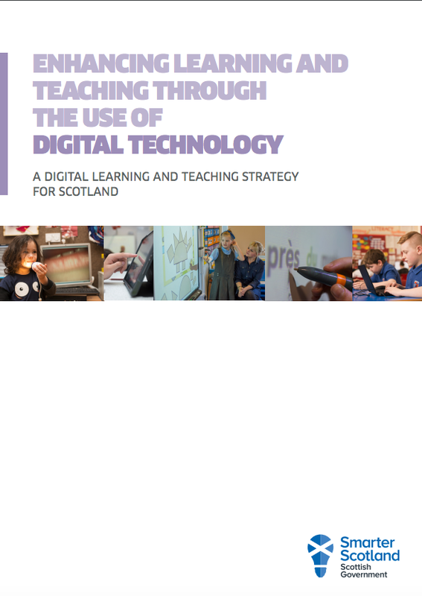
Recently the Scottish Government has released a national strategy that aims to ensure all learners and educators are able to benefit from digital technology in their education.

The document can be viewed and downloaded here.

We are entering a new phase in digital learning in Scotland with a government commitment to use digital technology to help close a growing attainment gap between rich and poor.
Education Secretary John Swinney has put excellence and 'equity' at the heart of a new strategy to equip schools, teachers and children with the digital tools they need to thrive.
The new national strategy was published in September and lays out four key areas of focus for the education establishment in Scotland for the next 3-5 years.

- Develop the skills and confidence of educators in the appropriate and effective use of digital technology to support learning and teaching.
- Improve access to digital technology for all learners.
- Ensure that digital technology is a central consideration in all areas of curriculum and assessment delivery.
- Empower leaders of change to drive innovation and investment in digital technology for learning and teaching.

Why do we want learners to have a personal device?
Learning is at the centre of everything we do. Teachers use a wide range of techniques to inspire, engage and support children and young people in their learning. These techniques include the use of technology and collaborative online tools. If these are used appropriately, digital technology can act as a powerful, flexible and engaging tool for educators that can enhance what they already do so well; teach our children and young people.

How Does Digital Technology Enhance Learning & Teaching?
- Access to a multitude of additional online educational content as well as being able to create new digital content that can support education.
- A range of digital tools and services (apps, games, websites, etc.) allow educators to offer a number of approaches to learning and learners can choose the approach that best suits them.
- Live video streaming and digital tools and services allow the potential for learners to study subjects via online distance learning.
- Educators have access to a range of engaging digital tools and services.
- Educators can reduce workload by using appropriate digital assessments that provide instant results and personalised feedback. This frees time for focusing on next steps and improvement.
- Educators can provide learners with access to a range of digital resources which allow ‘anytime/anywhere learning’ and build a level of digital skills which will be vital in today’s digital world.
- Online digital networks allow educators to share resources and digital tools and services expedite lesson planning. Digital assessment eliminates marking time. The time saved can be devoted to quality learning and teaching.
- Educators can offer learners the opportunity to collaborate online with others from across the world in addition to their peers within their school or early years setting.

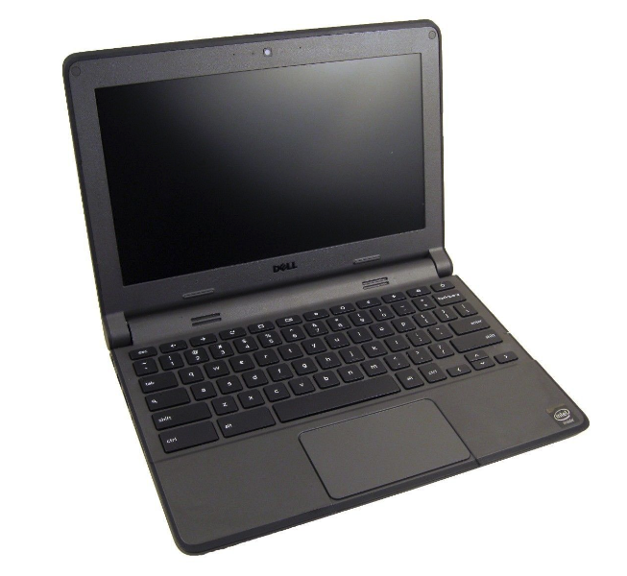
What is a Chromebook?
A Chromebook is type of device growing in popularity in education; it is essentially a Google Chrome Browser in a small light laptop style device. Offline functionality provides the opportunity to read webpages, pdf documents, read, edit, save and upload documents (including MS Office) when connectivity is re-established. Several apps will also work offline.

From August 2017 Chromebooks will be rolled out to every P6-S6 pupil in Highland. This is a key part of the Highland Council's priorities – Council Priority 32, ”We aim to provide our pupils with a technology-rich environment, to address their learner needs and curriculum goals, and transform their learning experience”. The one device per pupil model supports anytime, anywhere learning providing learners with access to school work, information and collaborating tools when and where they choose.

When a Chromebook is used pupils are required to login with a school / authority provided account. Highland has a G Suite for Education domain with pupil accounts and a dedicated administration / management console. The console provides a huge variety of settings that can be allocated to certain groups or individual devices with ease. E.g. access to login to the device, password resets and access to websites / apps. This provides a great platform for a learner device as there are many safety features that can be implemented without disrupting the learner experience.

Software cannot be installed onto the Chromebook like a Windows device but you have access to a wide range of educational apps and browser based content, tools and services.

A major educational draw of Google Docs is the ease of use of the collaborative documents, saved instantly with revision history and adding comments. The collaboration is 'real-time' and can include multiple users, rather than one pupil at one time editing the document. The visibility of real-time editing with multiple users is a powerful one for learning and teaching.

Any updates are installed without disruption and anti-virus software is not required. They are robust devices with very few breakages or errors reported in local authorities who have begun to use them.

They are very light, portable and due to the very minimal operating software they boot up to desktop in less than 7 seconds, another attractive feature for educational purposes, especially in a classroom setting. Operating time before recharge is at least 7.5 hours. Touch screen options with pinch / zoom are available thus giving the functionality / feel of tablet devices and a strong feature for visually impaired learners. They have HDMI, USB, SD Card ports therefore they can connect to projectors or peripheral devices easily.

They are multi-user devices; the pupil's login will only be to their own content and settings. However, because all content is stored in the cloud a pupil can also log into Chrome on any machine (including home and school PCs) and access their saved content, bookmarks and apps. They can also do this with their personal devices such as smartphones or tablets, this supports anytime, anywhere learning. The Google platform itself is therefore is ‘device neutral’. Chromebooks are also more affordable than Microsoft and Apple alternatives.

For more information about G Suite for Education and the Chromebooks please look at their website here.

Highland Digital Learning Website

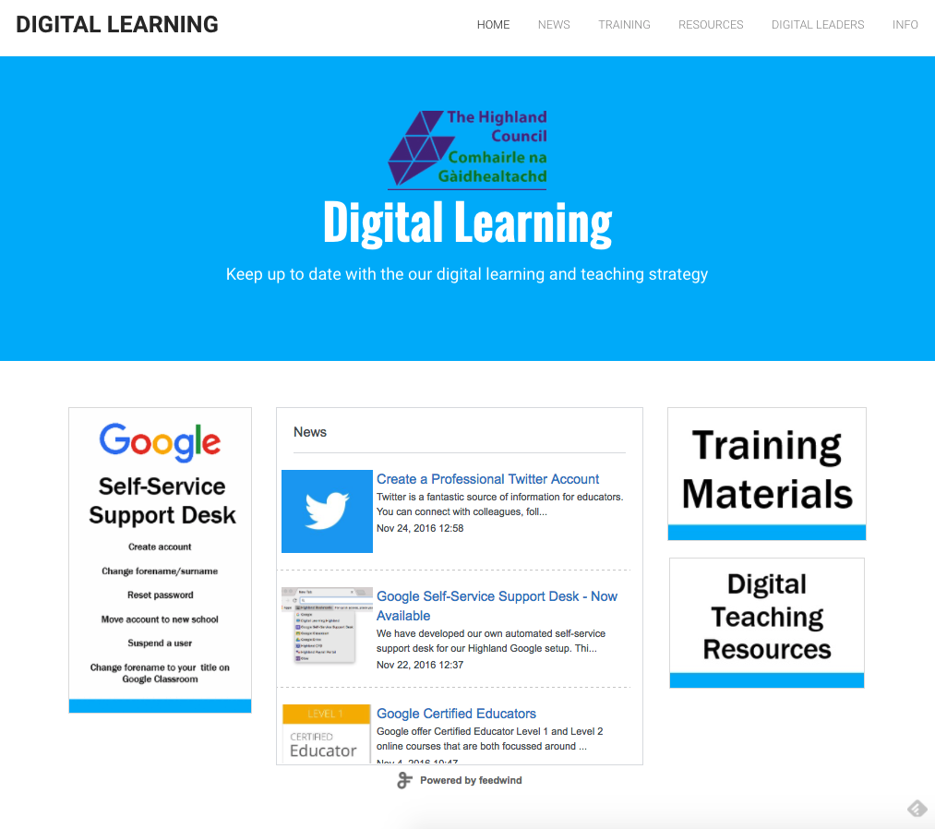
Digital technology is being used all over Highland to engage and inspire learners and this good practice will be shared on the news section along with other developments. This will give you an insight into how children and young people’s education is being enhanced using digital technology.

Access the website here, www.DigiLearnHighland.co.uk

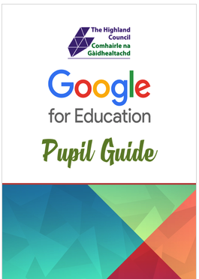
G Suite for Education Pupil Training Guide
If you would like to support your child with using GSuite for Education you can access the pupil guide from our website here.

Another great resource for support and video tutorials is the GSuite Training App. This is available to all pupils and can be accessed on all Chromebooks. For more info click here to watch a video tutorial on how to use it.

Safe and Responsible Use of Digital Technology
The bullet points below have been designed to help you get the most out of the technology that is available to you. They provide helpful tips and guidance for everyday life as well as setting out the expectations for using the digital technology in school.

1. Be Secure
- I will keep passwords to myself and not share them with anyone, even my close friends.
- I will always log out and log off my account on any the device that I am using.
- I will always lock my computer when I walk away from the screen (even for a short while).

2. Be Respectful
- I will always be polite and use appropriate language.
- I will not access, create, store or distribute files that could be thought of as offensive, indecent or cause hurt or upset to anyone.
- I will not look at anyone else’s files without their permission.
- I know that bullying using text, multimedia messaging, email or on social sites is unacceptable and may lead to very serious consequences.

3. Be Safe
- I will not share my personal information or other people’s (home address, phone number etc.)
- I will be wary of emails that ask me for any personal information.
- I will check with an adult about anything I see that concerns me or report it to a teacher.
- I will not put any personal details about other people into emails, posts, comments or updates.
- I will never meet up with anyone offline that I have only met online without a parent/carer or trusted adult.

4. Be Responsible
- I will think carefully about the places I go online and keep focussed when on learning tasks.
- I will take good care of the digital technology I use. I understand that if I am irresponsible in my use of digital technology, I may lose my access to it.
- I understand that I may be able to use my own device or mobile phone in school only at agreed times. If I use it in class without permission, my device may be temporarily confiscated and my parent / carer informed.

5. Be Legal
- I will only copy / upload / publish / distribute materials that are appropriate.
- I will only take images or video of other pupils, friends or staff with their full knowledge and permission.
- I will not copy / upload / publish / distribute images or videos of others without their permission.
- I know that I should not copy materials, music, videos or pictures from the internet and use them in my own work unless they are copyright free.
- I will remember that anything I do can be traced back to me including my browsing history and content that I may copy / upload / publish or distribute.

For more information, how to keep safe with any aspect of online / digital safety please go to www.thinkuknow.co.uk or www.childnet.com

Safe and Responsible Use of Digital Technology – Further Info
The Highland Council ensures pupils are provided with information regarding the kinds of behaviour that is expected of them when using digital technology in schools.

The expectations have also been designed to promote safe habits and behaviour that help pupils to use digital technology safely and responsibly both in and out of school. Using technology for learning and learning about technology is a vital part of education. This is particularly important as young people grow up in an increasingly digital world. The points below provide a starting point for schools to build on their programmes for Internet safety and responsible use and are also a useful tool for discussion at home.

Be Secure
The Highland Council provides every pupil with their own username and password to log on to the system. Each pupil has their own settings and filters on Internet access so they only access information suited to their age group. Pupils can also access their work from any device in the school. Sharing usernames and passwords to enable another person to log on is unsafe and is not permitted.

‘Treat your passwords like your toothbrush’ – as in never share and change them often! This is a fun way to get children and young people to think about their passwords. Sometimes people use the same password or phrase for all their accounts such as, Facebook, Instagram and Twitter. If this password is shared it allows someone to get access to many different sites and access your personal information on multiple platforms.

Sometimes children and young people like to show they trust their friends by letting them know their password. Try to ensure that pupils understand that they are protecting their friends by not giving them their passwords. It is advisable to have complex passwords or phrases which can prevent people guessing them or prevent specifically designed computer programs hacking accounts to gain access. Encourage pupil passwords to include a capital letter and a number where possible.

When finished using any device it’s important to ‘lock it’ or ‘log off’. Quite often pupils (and adults) multi-task and will walk away from the screen momentarily. Being mindful of logging off or locking the screen helps to protect ourselves and the equipment. If the device or machine is left open and the pupil is logged on, it may be possible for another user to access their files, pretend to be them and potentially cause mischief.

Be Respectful
The Highland Council promotes positive behaviour in school and the same behaviour is expected online. This point helps pupils to understand that that communication online is the same as in the offline world both in and out of school.

Bullying using electronic means has been referred to as ‘Cyberbullying’. Any form of abuse or bullying behaviour in school is not tolerated and will be dealt with as per the school’s anti-bullying approach.

Be Safe
Personal information online might attract unwanted email from hackers, unpleasant phone calls or messages, or being bombarded with advertising emails. If someone had all these bits of information collectively such information could provide enough detail to steal a person’s identity. It could be possible to open a fake account or take out a credit card or loan. It is important that pupils understand the need to protect their information and that they also have a responsibility to protect information belonging to others too.

This is a key principle that is taught across all e-safety education. Some pupils find it easy to build up trust with someone they haven’t met before, either through gaming or social media - not all people are who they say they are online. It is important to explain that ‘no matter how much you think you know someone and develop a friendship with them, you must never meet up with anyone without your parent, carer or trusted adult’.

Although the internet in school has a filter in place, sometimes pupils may see something that worries them or they are not emotionally ready for. This may be content on a website, text/images in a document or a message/posting online. Seeing something like this this is not exclusive to unpleasant sites but often adverts or news items are not suitable for children or young people. It is important to encourage pupils to tell someone if they see content they find offensive so that the teacher or adult can take action. This may be reporting a website to an agency like the Internet Watch Foundation, adjusting filtering settings or simply being supportive with advice and explanations.

Be Responsible
In schools, the Internet is filtered in a way that allows access to websites relevant for pupils to enable them to be creative, carry out research for their learning and look at sites relevant to education. The filter prevents access to websites which contain content that is not appropriate without being prohibitive to learning.

However, some pupils can access the unfiltered Internet on their personal devices such as smartphones, tablets, gaming devices, smart TV and computers at home. For these reasons pupils are encouraged to think about how to search for information responsibly. Think critically about content online and be responsible about the websites visited on the Internet.

Be Legal
Using files, images or pictures which belong to someone else can lead to infringement of Copyright Legislation or upsetting for the owner.

In any use of the Internet, it’s important to encourage pupils to think about the content of photos or video that they might upload themselves. Is this something they wish to share online? Content is out with anyone’s control once posted; other people may share it too. It’s also important to think about the future. A digital “footprint” is being created which can paint a picture of a person which can be found in the future.

Tips for Parents and Carers

Children and young people are living in an increasing digital world; they just do not simply ‘go online’. The tips below can help in discussing with your child how to keep safe.

- Keep talking. Lead the way by introducing safety the way you would about any other safety topic. It can be as simple as discussing what to do with a family photo.
- Be a good role model; contribute to safer online communities by encouraging responsible use and good use of technology.
- Be prepared to talk about violent, self-generated images or sexualised content - it’s what concerns them.
- Ask them what a ‘friend’ is, what does this mean to them?
- Make sure they know who they can speak to if they see or hear anything that concerns them.
- Keep reminding your children to ‘think before they post’, whether it is something about themselves, an image, a video clip, an update or a ‘like’ it is going to be out with their control as soon as it’s posted.
- Ask them to think about password safety, what would happen if someone had all their passwords?!
- Ask them to challenge, be critical, and question what they see online.
- It is never too late to report.
- Remind them NEVER to meet up with anyone offline they have met online.

For more information and support please go to www.thinkuknow.co.uk this is a website that is promoted in school as it has educational materials for all ages as well good information for parents / carers.

If you wish to report a website that concerns you, you can do this at www.iwf.org.uk.

If you are concerned about a child - tell someone what your concerns are – speak to a teacher, a doctor, a social worker, a police officer or school nurse.

The Highland E-Safety Website also contains further information www.highlandesafety.wordpress.com

What we expect from pupils
Pupils will have already signed an ICT acceptable use policy when they enrolled in school. A Chromebook agreement will be reissued when the Chromebook is provided.

We ask pupils to:
- Only use a Chromebook in a lesson when directed by a teacher.
- Take care of their Chromebook.
- Ensure the Chromebook is fully charged before it is brought into school.
- Follow the safe and responsible use guidelines.

What won’t change?
Learners will continue to write by hand and use textbooks alongside Google Docs and Google Slides. SQA exams are still taken with pen and paper, and because it’s a valuable skill, it’s important to remember learners still need plenty of opportunities to write by hand. In some lessons Chromebooks will not be used at all, as learners are expected to talk, discuss and write independently.

We do not want learners spending all their time looking at a screen so it’s important to make lessons flexible and varied. Teacher and learner interactions will always be the highest value as well as active and practical learning opportunities. Chromebooks and any other form of digital technology should only be used when it can enhance the learning opportunity.

Learners will continue to be encouraged to read and use textbooks. In Highland, we have fantastic libraries within schools and these are full of brilliant resources for learning. Chromebooks can complement this and will be used to provide access to a wealth of literature from additional sources.

Safety & Security
All the large technology companies have an education platform. These platforms are different to consumer accounts and they must comply with additional laws. In the UK, large technology companies must show compliance of the Schools Service Checklist for Cloud Services to be approved for use in schools. Google has completed this and can be viewed here.

Our Highland setup is used purely for learning materials and is not used to hold any personal or sensitive data. All local authorities in Scotland use a secure management information system called SEEMiS. This is used to store personal data such as contact addresses, emergency contacts, subject reports etc. Google have confirmed that GSuite for Education will remain free for educational use and there will be no adverts within the GSuite for Education apps unlike the ones you see in third party products. More information about student data privacy from Google here.

Our setup allows us to have control of what apps are available to learners. Apps such as Google+ is currently turned off for all students. Our vision is to be as supportive of learning as possible whilst ensuring safety and security at the same time.

Making the switch to a Chromebook (for pupils)
 | Windows Device |  | Chromebook
 | Microsoft Word |  | Google Docs | 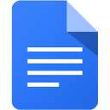
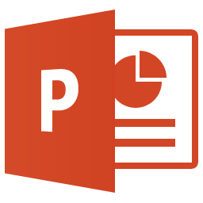 | Microsoft PowerPoint |  | Google Slides | 
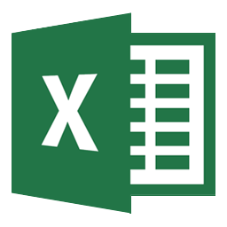 | Microsoft Excel |  | Google Sheets | 
 | Internet Explorer |  | Google Chrome | 
 | My Documents |  | Google Drive | 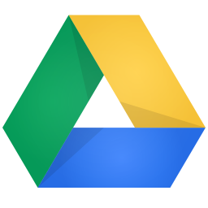
 | Pupil Shared |  | Google Classroom | 
 | Skype |  | Google Hangouts | 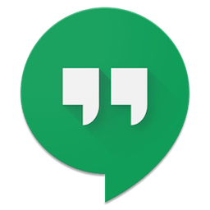
 | Snipping Tool |  | Built in feature   | 
 | Google Earth |  | Google Maps | 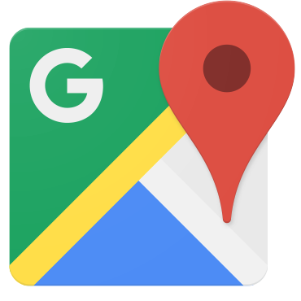
 | Email Account |  | GMail | 
 | Calendar |  | Google Calendar | 
 | Image Editing - Animation/Video Creation - Web Page Creation  Adobe Spark

Digital Resources for Everyone
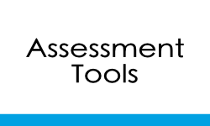 | 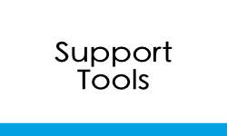 | 
Digital Resources
 |  | 
 |  | 
 |  | 
 |  | 
 | For more resources please check out www.DigiLearnHighland.co.uk/resources.html

Chromebook FAQ

What kind of software does a Chromebook run?
Chromebooks run millions of web-based applications, or web apps, that open right in the browser. You can access web apps by typing their URL into the address bar or by installing them instantly from the Chrome Web Store.

How are these web-based applications managed?
Each Chromebook we provide to students will be a managed device. We will maintain devices through a learners GSuite for Education account. As such, the school can pre-install web-applications as well as block speciﬁc web-applications from a management console.

What devices can I connect to a Chromebook?
Chromebooks can connect to:
- USB storage, mouse and keyboard.
- SD cards
- HDMI, external monitors and projectors
- Headsets and microphones

Can the Chromebook be used anywhere at any time?
Yes, if you have a Wi-Fi signal to access the Internet. Google Chrome also offers the ability through various Apps so users can work in an "ofﬂine" mode if required.

In school, it is at the discretion of the teacher when a device should be used.

Does a Chromebook come with Internet Filtering Software?
No. Chromebooks do not come with internet ﬁltering software. However, while in school Chromebooks will use the school’s Wi-Fi to access the Internet which is ﬁltered. While at home, the Chromebooks will be ﬁltered based on the protection provided by your home Wi-Fi system. Advice on setting up parental controls at home can be found here.

Is there antivirus software built in?
It is not necessary to have antivirus software on a Chromebook because there are no running programs for viruses to infect.

A Chromebook uses defence-in-depth technology with layers of protection against malware and security attacks. Files are stored in the cloud, so there’s no need to worry about lost homework.

What is the battery life?
Chromebooks have a rated battery life of 7.5 hours. However, we do expect that students charge them each evening to ensure maximum performance during the school day

Can I use my personal Google account for school?
No. Personal accounts do not have access to GSuite for Education tools such as Google Classroom and are not managed within our Highland GSuite for Education domain. Highland Chromebooks are locked down so that only Highland Google accounts can be logged into them.

Can I print from a Chromebook?
With the use of Google Classroom and being able to share documents instantly the need for printing is reduced. If a document needs to be printed from a Chromebook the advice would be to share the document/email it to a teacher and they can then print it off, if required. At home your device may connect seamlessly with a WiFi printer using Cloud Print. More information can be found here.

Can I use my Highland Google account when setting up a personal Android smartphone or tablet?
No. If you are setting up a personal Android smartphone or tablet you should create your own Google account for this. When the pupil leaves education their account will be deleted and this will impact on your personal devices if you use your Highland account. Once your personal smartphone or tablet is set up you are able to use your Highland Google account to login to Google Classroom, Google Drive, GMail and access your files.

How do I update my Chromebook?
When a Chromebook starts up, it updates itself automatically, so it has the most recent version of the Chrome OS operating system without you having to do a thing.

